FREQUENTLY ASKED QUESTIONS - CLIENT

Sage Intacct Financial Integration

Last Revised: April 28, 2023
Questions (Click to see the answers)
About Sage Intacct 1
1. Which markets support the Sage Intacct Financial integration? 1
2. Which version of Sage Intacct does the Sage Intacct Financial integration connector support? 1
3. How will out-of-pocket expense transactions be posted to Sage Intacct? 1
4. Can I post a credit card transaction as a bill or to my credit card bank account? 1
5. When posting credit card transactions to the credit card bank account, If the February claim contains January transactions & January Month End has been closed in Sage Intacct, will these transactions post to Sage Intacct? 1
6. When a credit card transaction is posted as a bill, what date will post? 1
7. How will AP Invoices post to Sage Intacct? 1
8. How should I handle making changes to master data in Sage Intacct—for example, deleting an account? 1
9. Can I connect multiple Sage Intacct entities to one SAP Concur account? 2
10. Can I post to top-level entity only? 2
11. How many entities can I post to with the Sage Intacct Integration? 2
12. I have connected to SAP Concur, however I am not seeing all of my data, like child entities, accounts & vendors? 3
13. I only want to bring in certain entities, how do I ensure only the entities I want are brought into Concur upon connection? 3
14. What happens if I have duplicate ID numbers in Sage Intacct? 3
Connection to Sage Intacct 4
15. How do I connect my SAP Concur account to Sage Intacct? 4
16. What type of user should I use when connecting to SAP Concur? 5
17. I am getting the following error when I try to connect to SAP Concur: “Entity slide is disabled for this company. Sign on information is incorrect” How do I resolve this error? 5
18. I have connected SAP Concur to Sage Intacct, however I don’t see certain data—for example, accounts, dimensions, or vendors—in SAP concur. 5
19. I have added the SAP Concur sender ID to Sage Intacct, however I am still getting an error when trying to connect? 6
Accounts 6
20. How do I refresh accounts from Sage Intacct in Concur Expense and Concur Invoice? 6
21. I only see my account name, not my GL account number. 6
22. What account types are supported by the integration? 6
23. I have removed all the required dimensions from my GL account, however I am still getting the following error: 7
"Spend Management is configured to validate the transaction including multiple dimensions, but this transaction only specifies Location. Post the transaction again, including the missing dimensions." 7
Cost Tracking 7
24. I don't have an option to enable alternate account codes in my custom fields list. 7
25. Do Concur Expense and Concur Invoice support dimensions? 8
26. How do I refresh dimensions/cost tracking objects from Sage Intacct to Concur Expense and Concur Invoice? 8
27. Can I post billable transactions to Sage Intacct? 8
Vendors 8
28. How do I add users from Sage Intact to SAP Concur solutions? 8
29. How do clients distinguish employee vendors from account vendors in Sage Intacct Accounting? 8
30. How do I refresh employee vendor data from Sage Intacct Accounting? 8
31. How do I refresh account vendor data from Sage Intacct Accounting? 9
32. Is ACH information included as part of the vendor master record when sending vendor master data via the Sage Intacct connector? 9
33. Why am I getting an error when I try to add large numbers of vendors? 9
34. Will vendors created in SAP concur sync back to Sage Intacct? 9
35. I only want to post transactions to my credit card bank account or credit card vendor. Do I still need to set up all users as a vendor in Sage Intacct Accounting? 9
Tax Codes 9
36. Does the Sage Intacct integration support VAT/GST? 9
Posting Bills and Credit Card Transactions to Sage Intacct 9
37. Can I post a credit card transaction as a bill or to my credit card bank account? 9
38. I am using Concur pay to reimburse my employees, will the integration close out the employee vendor bills? 10
39. If the February claim contains January transactions, and January month end has been closed in Sage Intacct, will the January transactions post to Sage Intacct? 10
40. On the Payment Types page, what is consolidated vendor handling used for? 10
41. When I post, I get the following error and cannot create the transaction: 10
“The account number 6020 requires a restriction (class)" 10
42. Posting failed with the following error: 11
“You do not have permission for API operation CREATE on objects of type ap bill." 11
43. I get the following posting error: 11
“The system was unable to process the document, Entity <ABC> is not matching with custom field entity." 11
44. I get a posting error similar to the following: 11
“Smart rule restriction requirement violated. You must provide a restriction on every line.” 11
45. I get the following posting error: 11
"The system was unable to process the document. The vendor does not exist in this entity." 11
46. When the CC transactions are posted to one main account in Intact, does it indicate which employee's transaction it is? 11
47. Some entity dimension data is not showing on the custom fields page. 11
48. I get the following posting error when I post to my credit card account in my Cash Management Module: 12
“Error Processing Document processing failed: The credit card ‘XXXX’ is not valid. Currently, we can’t create the transaction.” 12
49. When posting a credit card transaction to the Cash Management Module, what value will post to the payee section in Sage Intacct? 13
50. We use the “Time and Expense” section of Sage Intacct to process our travel and expense transactions. Does SAP Concur support posting to “Time and Expense”? 13
Connecting and Disconnecting 13
51. How can I confirm that I have connected Sage Intacct to SAP Concur solutions? 13
52. What if I need to disconnect from Sage Intacct Accounting? 14
53. What happens if I delete and entity in Sage Intacct? 14

About Sage Intacct

Which markets support the Sage Intacct Financial integration?
- US

Which version of Sage Intacct does the Sage Intacct Financial integration connector support?
- US
The Sage Intacct connector does not support multicurrency transactions. All transactions from SAP Concur will post to Sage Intacct in the home currency of Sage Intacct.

How will out-of-pocket expense transactions be posted to Sage Intacct?
- Out-of-pocket expense transactions post to Sage Intacct as bills.

Can I post a credit card transaction as a bill or to my credit card bank account?
- Yes, clients have the option to post transactions as a bill to the credit card vendor name or post the transactions to the credit card bank account.

When posting credit card transactions to the credit card bank account, If the February claim contains January transactions & January Month End has been closed in Sage Intacct, will these transactions post to Sage Intacct?
- No, for credit card transactions posting to the credit card bank account we post the credit card transaction date so if the transaction date is from January and January is closed then yes this is true. Sage Intacct will not allow adding transactions once the month is closed. This will cause the transaction to fail to post.

When a credit card transaction is posted as a bill, what date will post?
- The transaction date that will post is based on bill posting preferences that is selected in the SAP Concur set up.

How will AP Invoices post to Sage Intacct?
- AP invoices will post to Sage Intacct as bills.

How should I handle making changes to master data in Sage Intacct—for example, deleting an account?
- Prior to making changes, the administrator should notify users to stop submitting expense reports/invoices and then wait for all submitted reports/invoices to finish the approval/sync process. Then the administrator can make changes in Sage Intacct and update the synchronized data in Concur Expense and/or Concur Invoice. Once all the changes have been synchronized, the users can start creating and submitted reports/invoices again.

Can I connect multiple Sage Intacct entities to one SAP Concur account?
- Yes, once connected to Sage Intacct, Concur Expense and/or Concur Invoice will pull in all entities from Sage Intacct. You can only connect one Sage Intacct company file to one SAP Concur account; however, all entities in that one Sage Intacct company will pull into Concur Expense and/or Concur Invoice.

Can I post to top-level entity only?
- Yes, SAP Concur has added an option for clients to select posting top level only when connecting.
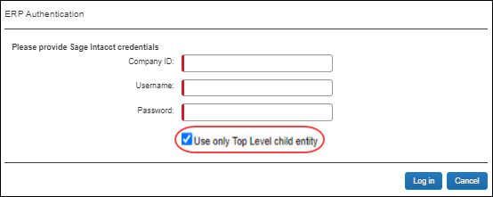
After selecting the Use only Top Level child entity, when clients navigate to the accounting page in Product Settings, the following message is presented:
"You are using the Top Level child entity."
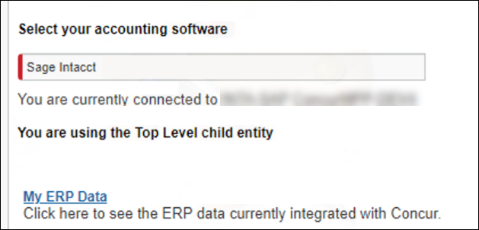
If you want to post at the entity level and you are an existing, connected Sage Intacct customer, you must disconnect and reconnect SAP Concur to Sage Intacct. SAP Concur supports a maximum of 10 entities.

How many entities can I post to with the Sage Intacct Integration?
- The maximum number of entities you can post to is ten.
If you only need to post to the top-level entity or fewer than 10 entities, you can still use the SAP Concur integration. You can add the entities (including the top-level entity) to the web services user who is connecting SAP Concur to Sage Intacct.

I have connected to SAP Concur, however I am not seeing all of my data, like child entities, accounts & vendors?
- You can check the permissions in the user profile. SAP Concur has full permissions to ALL modules, Company (which will pull in the entities), AP module, etc. There are 2 types of user permission
- Users: Grant permissions in User-based instance
- Navigate to Company > (Admin) > Web Service User
- Find your user and click SUBSCRIPTIONS towards the right side.
A page that lists all the modules appears.
- Click Permissions for each module.
- Roles: Ensure the role has access to ALL Sage Intacct modules

I only want to bring in certain entities, how do I ensure only the entities I want are brought into Concur upon connection?
You must add the entities to the web services user who connects to SAP Concur.
- Navigate to Company > (Admin) > Web Service User
- Find the user and click EDIT
- Click on the User Entities tab and include the specific entities
- Click SAVE

What happens if I have duplicate ID numbers in Sage Intacct?
- ID numbers must be unique. Duplicate ID numbers will cause issues when data is imported into SAP Concur.
- IMPORTANT: Sage Intacct treats ID numbers as case sensitive. As such, two ID numbers with the same alphanumeric characters but different use of upper and lower case is considered unique in Sage Intacct. SAP Concur does not treat ID numbers as case sensitive, so two ID numbers with the same alphanumeric characters are considered duplicates even if upper and lower case is applied differently to each ID.

Sage Intacct has a regular maintenance window every Friday from 7:30 PM to 11:30 PM PST:
https://www.sageintacct.com/system-status

Connection to Sage Intacct

How do I connect my SAP Concur account to Sage Intacct?
- Select Intacct as your accounting software in the accounting setup, click the Sage Intacct button, enter your Company ID, Username, and Password, and then click Log in.
If the admin who connect Sage Intacct to SAP Concur changes their password, they must disconnect and then reconnect.
For existing customers, all existing expense reports or invoices, including reports and invoices that have not yet been submitted, must be approved and processed and payment batches must be closed before establishing the integration connection.
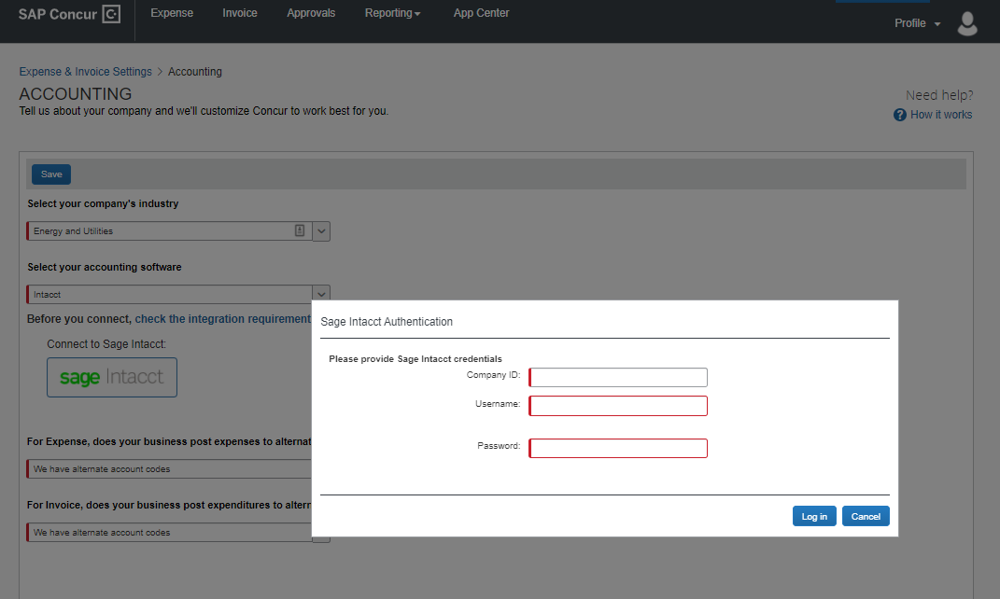
- After connecting to Sage Intacct for Concur Expense and/or Concur Invoice you must enable alternate account codes

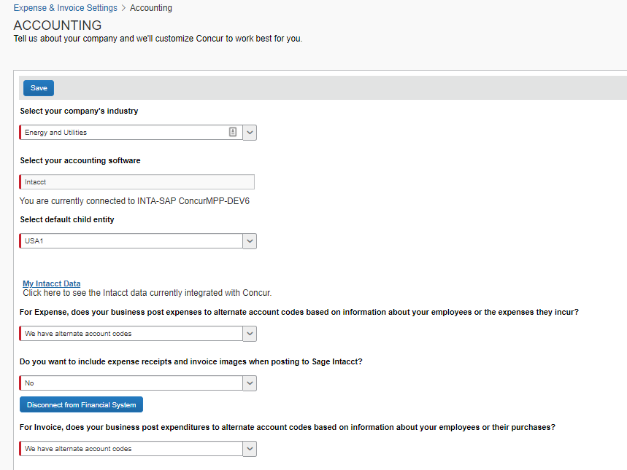
- Optional: You can choose to post receipt images and invoice images back to Sage Intacct.

What type of user should I use when connecting to SAP Concur?
- It is best practice to use a web service user when connecting to SAP Concur.
- Normal admins can change their password, which will break the connection. Some companies (depending on their role) will have to change their passwords based on the company policy. If the admin leaves the company and the user is deactivated, then the connection to SAP Concur will break and need to be re-established.
- The Webservice user does not belong to any user, so, if a company does not have any password policy, user permissions need to be adjusted depending on their role in organization.

I am getting the following error when I try to connect to SAP Concur:
“Entity slide is disabled for this company. Sign on information is incorrect” How do I resolve this error?
- In Sage Intacct, go to Company > admin > Subscriptions, scroll down to Multi-Entity Console and click Configure, and then uncheck the box labeled Restrict access to top-level only.
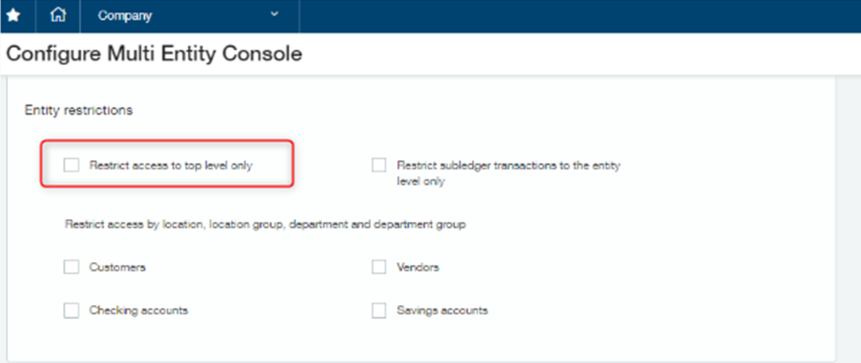

I have connected SAP Concur to Sage Intacct, however I don’t see certain data—for example, accounts, dimensions, or vendors—in SAP concur.
- Check the web service user's permissions and ensure that the user has access to ALL Sage Intacct modules.
- If using role-based security go to Company->Roles.
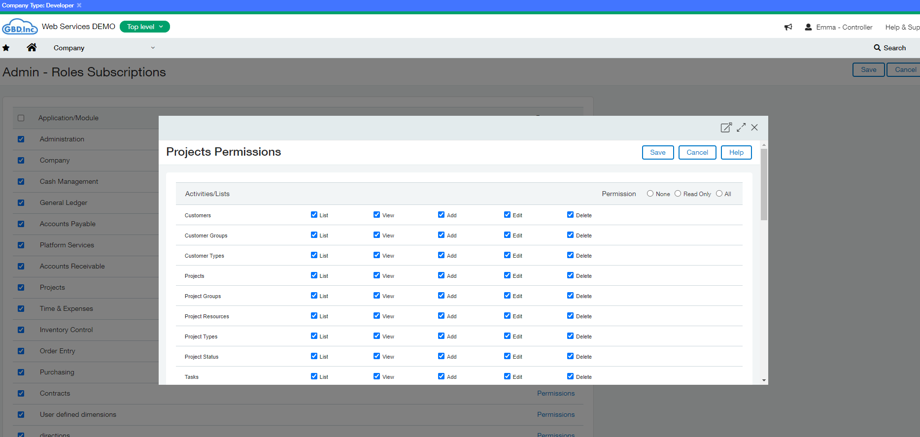
- If using user-based security instead of role-based security, grant permissions in user-based instance:
- Navigate to Company > (Admin) > Web Service User.
- Find your user and, on the right side, click Subscriptions.
- On the page that lists all of the modules, click Permissions for each module.

I have added the SAP Concur sender ID to Sage Intacct, however I am still getting an error when trying to connect?
- If the sender ID has been added and the web services user has all full permissions, confirm whether the Enforce Content Security policy is enabled. If it is enabled, disable it and try to connect SAP Concur to Sage Intacct.
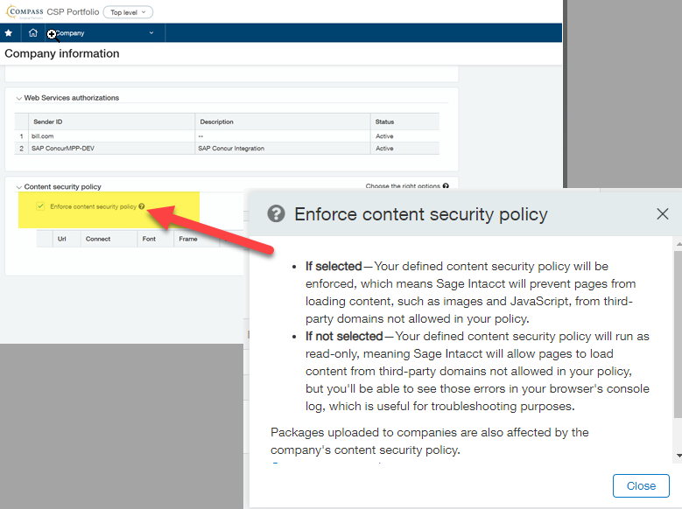

Accounts

How do I refresh accounts from Sage Intacct in Concur Expense and Concur Invoice?
- Account data is cached and will update every hour. If a user searches for a new or updated account during the time the cache is still stale, they will not find the account in the SAP Concur system. The SAP Concur administrator can manually invoke a refresh by clicking the refresh button on the My Sage Intacct Data page.

I only see my account name, not my GL account number.
- At this time, SAP Concur displays the account name not the GL number.

What account types are supported by the integration?
- For mapping expense types in Concur Expense and/or Concur Invoice:
- You must select the top level or child entity in the Accounting set up screen to map data in Concur Expense and/or Concur Invoice.
- Sap Concur solutions filters accounts that can be mapped to expense types.
- The following account types can be mapped on the expense type page:
- Other Current
- Assets
- Fixed Assets
- Expense
- Other Expense
- Cost of Goods Sold
- Other Current Liabilities.
- For mapping liability accounts:
- You must select the child entity in the Accounting set up screen to map data in Concur Expense and/or Concur Invoice.
- You do not need to map liability accounts for employee reimbursements.
- For credit cards: SAP Concur solutions pulls in the credit card bank account for the entity that was selected in the Accounting set up screen.
- For mapping clearing account codes:
- You must select the child entity in the Accounting set up screen to map data in Concur Expense and/or Concur Invoice.
- Sap Concur solutions brings in asset accounts to map the clearing account codes to.

I have removed all the required dimensions from my GL account, however I am still getting the following error:

"Spend Management is configured to validate the transaction including multiple dimensions, but this transaction only specifies Location. Post the transaction again, including the missing dimensions."
- Navigate to Company > Company > Admin > Subscription > Spend management > Configure also will help

Cost Tracking

I don't have an option to enable alternate account codes in my custom fields list.
- To use alternate account codes with the Sage Intacct integration you must have a single level custom field. This field is automatically created upon connection, if this custom field is deleted, you must create a new single level list to use with alternate account codes. This is required for setting up your expense types

Do Concur Expense and Concur Invoice support dimensions?
- Yes, you can select and map your Sage Intacct dimensions (cost tracking objects). Concur Expense and Concur Invoice will only pull in active tracking categories.

How do I refresh dimensions/cost tracking objects from Sage Intacct to Concur Expense and Concur Invoice?
- Once dimension options are added into Sage Intacct, they will populate in SAP Concur solutions when navigating back to the Custom Fields page in Product Settings.
You can refresh by logging into the home page and/or waiting one hour to refresh.

Can I post billable transactions to Sage Intacct?
- Yes, when posting billable transactions, you must select a customer and an item, or the transaction will fail to post.
- IMPORTANT: When mapping Sage Intacct dimensions to SAP Concur custom fields, you must create a list, map the list, and then save the list before moving on to the next list. You must do this for each list. Do not attempt to map all of the lists at the same time or the lists will not be imported into SAP Concur.

Vendors

How do I add users from Sage Intact to SAP Concur solutions?
- Clients typically set up their employees as vendors in Sage Intacct Accounting. Vendors must be entered into Sage Intacct with first name, last name, and email address.

How do clients distinguish employee vendors from account vendors in Sage Intacct Accounting?
- Sap Concur solutions filter based on the presence of a first name, last name, and email address.

How do I refresh employee vendor data from Sage Intacct Accounting?
- Employee contact (Vendor) data is refreshed by clicking the Add Users from Sage Intacct Accounting” button on the Users page in Product Settings.
- Employee contact (Vendor) data is refreshed immediately; there is no delay.

How do I refresh account vendor data from Sage Intacct Accounting?
- Account vendor data is refreshed by clicking the Add Vendors from ERP button on the Manage Vendors page.
- Account vendor data is refreshed immediately; there is no delay.

Is ACH information included as part of the vendor master record when sending vendor master data via the Sage Intacct connector?
- No. ACH information is included when sending vendor master data.

Why am I getting an error when I try to add large numbers of vendors?
- Clients with large amounts of data might encounter timeout issues. SAP Concur makes live API calls when trying to fetch and post data. Try adding between 50 and 100 vendors/users at a time.

Will vendors created in SAP concur sync back to Sage Intacct?
- No. SAP concur does not create a new vendor profile in Sage Intacct. SAP Concur treats Sage Intacct as the source or truth. All employee and AP vendors must be created in Sage Intacct first, and then be pulled into SAP Concur.

I only want to post transactions to my credit card bank account or credit card vendor. Do I still need to set up all users as a vendor in Sage Intacct Accounting?
- Yes. All users in SAP Concur must be set up as a vendor with first name, last name, and email address in Sage Intacct. This is required to set up a user in SAP Concur.

Tax Codes

Does the Sage Intacct integration support VAT/GST?
- No.

Posting Bills and Credit Card Transactions to Sage Intacct

Can I post a credit card transaction as a bill or to my credit card bank account?
- Yes, clients can post transactions as a bill to the credit card vendor name or post the transactions to the credit card bank account.

I am using Concur pay to reimburse my employees, will the integration close out the employee vendor bills?
- No, you must manually close out the bills in Sage Intacct. Clients must use only payment manager to close out the Concur pay batch to trigger the payment demand. They will not get an extract to post into Sage Intacct. At the processor level, upon approval, the expense reports will post as a bill into Sage Intacct to the employee vendor name. Clients must then go into Sage Intacct to close out those bills. Currently, there is not an API to post payment confirmations back to Sage Intacct to close out the bills

If the February claim contains January transactions, and January month end has been closed in Sage Intacct, will the January transactions post to Sage Intacct?
- For Credit card transactions posting to the credit card bank account we post the credit card transaction date. If the transaction date is from January and January is closed then those transaction will NOT post to Sage Intacct; however, you can post credit card transactions to the credit card bank account OR as a bill to the credit card vendor name. When posting bills, we post based on bill posting preferences.

On the Payment Types page, what is consolidated vendor handling used for?
- Consolidated vendor handling is used when clients have credit card feed transactions coming into SAP Concur. It is best practice to use consolidated vendor handling for credit card transactions. SAP Concur first looks for the vendor name (exact match) in the ERP. If the vendor name is not there, SAP Concur creates a new vendor. When using consolidated vendor handling, SAP Concur will look for the vendor name in Sage Intacct. If an exact match for that specific vendor name is not found, SAP Concur will not create a new vendor but will post to the “dummy” vendor. This prevents multiple vendors from being created in Sage Intacct.
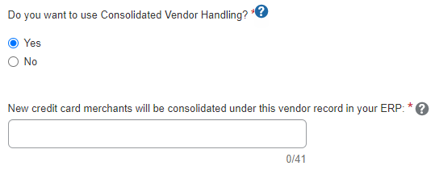

When I post, I get the following error and cannot create the transaction:

“The account number 6020 requires a restriction (class)"
- Clients who receive this error must look at their GL account 6020 in Sage Intacct and remove the requirement for the dimension of class. To ensure all transactions post successfully, it is best practice not to require dimensions on GL accounts.

Posting failed with the following error:

“You do not have permission for API operation CREATE on objects of type ap bill."
- Clients must look at the web service users permissions in Sage Intacct. The user that connects must have read/write access to all modules.

I get the following posting error:

“The system was unable to process the document, Entity <ABC> is not matching with custom field entity."
- When posting to an entity or location, the dimension must match the location to which you are trying to post.

I get a posting error similar to the following:

“Smart rule restriction requirement violated. You must provide a restriction on every line.”
- This is a permission in Sage Intacct. You must go into Sage Intacct and remove the smart rules.
Example smart rule:
The bill total must equal the total of the entered lines.

I get the following posting error:

"The system was unable to process the document. The vendor does not exist in this entity."
- Vendors must be in the location to which you are trying to post.

When the CC transactions are posted to one main account in Intact, does it indicate which employee's transaction it is?
- The employee name is in the description of the credit card transaction.

Some entity dimension data is not showing on the custom fields page.
- Confirm what type of accounts/data the client is trying to pull in. The integration does not support Accounts Receivable, and some dimension data could be in the AR accounts.

I get the following posting error when I post to my credit card account in my Cash Management Module:

“Error Processing Document processing failed: The credit card ‘XXXX’ is not valid. Currently, we can’t create the transaction.”
- This error typically occurs because the credit card has expired in Sage Intacct. Update the expiration date in the Sage Intacct Cash Management Module. Once the expiration date is updated, recall the report and approve it.
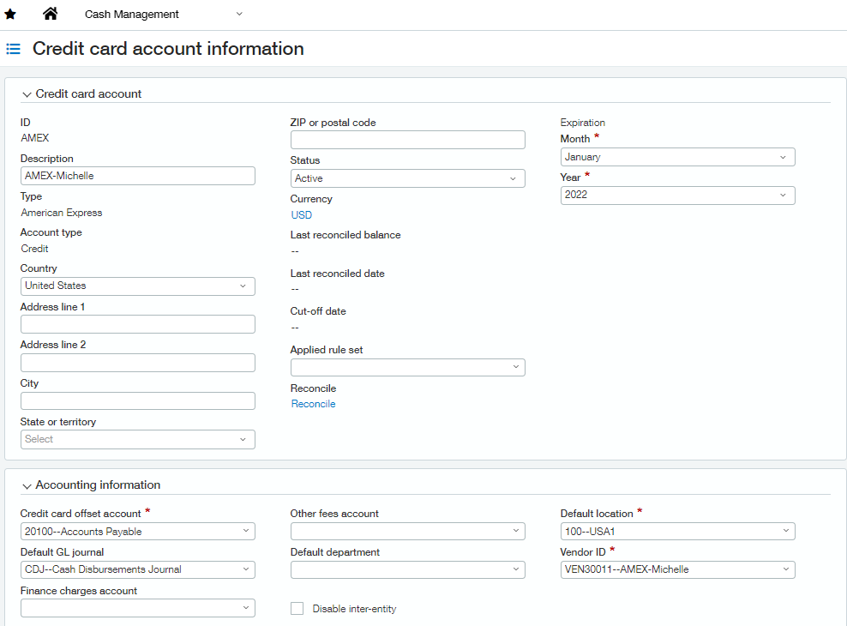

When posting a credit card transaction to the Cash Management Module, what value will post to the payee section in Sage Intacct?
- The vendor description in SAP Concur will post to the payee section in Sage Intacct.
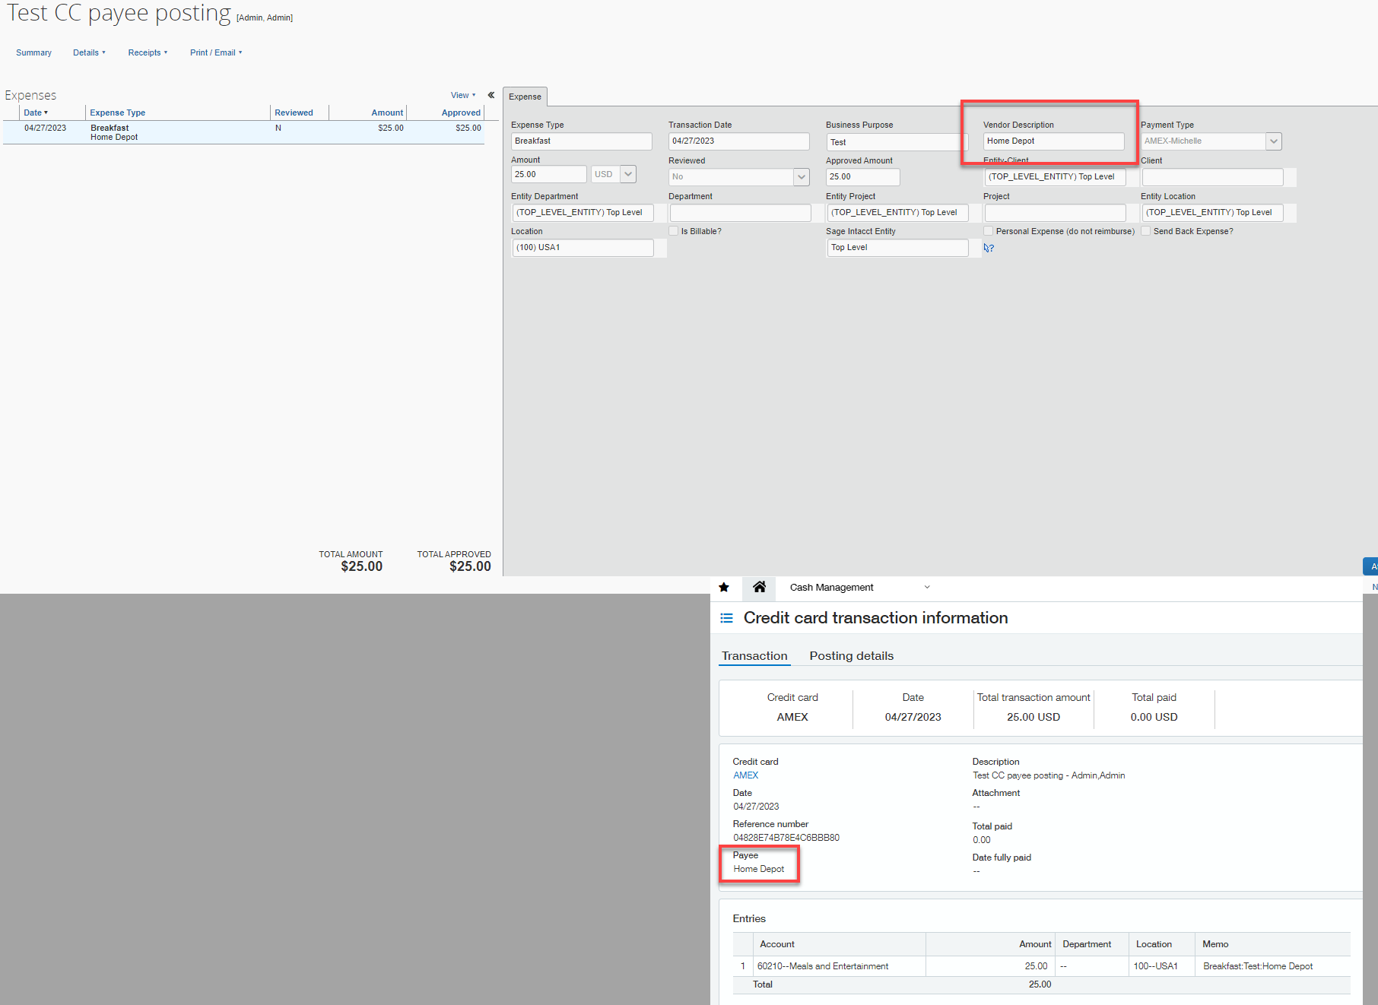

We use the “Time and Expense” section of Sage Intacct to process our travel and expense transactions. Does SAP Concur support posting to “Time and Expense”?
- No. The SAP Concur integration posts as a bill or to the credit card bank account in Sage Intacct.

Connecting and Disconnecting

How can I confirm that I have connected Sage Intacct to SAP Concur solutions?
- In SAP Concur Product Settings, on the Accounting page, you will see Sage Intacct displayed as the selected accounting software. Under the selected accounting software, you will see a message similar to the following:
You are currently connected to [Sage Intacct account name]-123146376969944

What if I need to disconnect from Sage Intacct Accounting?
- Clients cannot disconnect from Sage Intacct while reports or invoices are in-flight. This restriction includes reports and invoices that have been created but not yet submitted.
- After clicking the Disconnect button, if any reports or invoices are in-flight, the admin will see a screen listing all the in-flight reports and/or invoices. The list of in-flight reports and/or invoices can be exported to an excel file.
- If there are no in-flight reports or invoices, the admin can disconnect from Sage Intacct Accounting.

What happens if I delete and entity in Sage Intacct?
- If an entity is deleted in Sage Intacct, all reports that are tied to that entity will fail to post and data will no longer be pulled into Concur Expense and/or Concur Invoice from Sage Intacct.
- If you need to delete an entity, please ensure all expense reports/invoices are posted to Sage Intacct before deleting an entity.
- To help to ensure all reports successfully post to Sage Intacct, delete the existing SAP Concur mappings that are completed for that entity.

